1G

📞 What Is 1G (First Generation Mobile Network)?
# Source: Chatgpt (GPT-5-Mini) at [1/23/2026]
1G stands for First Generation of mobile network technology. It was the first type of wireless cellular communication, introduced in the 1980s, and used analog radio signals to transmit voice calls only — no text, no internet.
📻 1G was like a radio-based phone call system — bulky, noisy, and insecure, but revolutionary for its time.

📅 Quick Facts about 1G:
# Source: Chatgpt (GPT-5-Mini) at [1/23/2026]
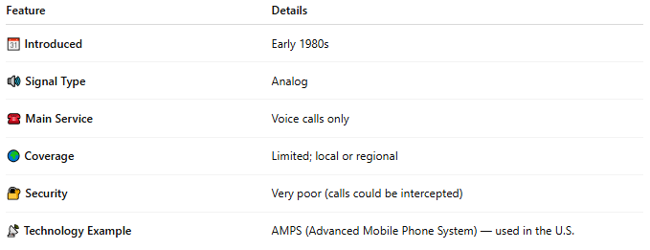

Feature | Details
📆 Introduced | Early 1980s
🔊 Signal Type | Analog
☎️ Main Service | Voice calls only
🌍 Coverage | Limited; local or regional
🔐 Security | Very poor (calls could be intercepted)
📡 Technology Example | AMPS (Advanced Mobile Phone System) — used in the U.S.

⚙️ How 1G Worked:
# Source: Chatgpt (GPT-5-Mini) at [1/23/2026]
- Used frequency modulation (FM) over radio waves.
- Each phone call got a dedicated frequency (inefficient).
- Connected to base stations via analog channels.
- No encryption — calls were not private.

📉 Limitations of 1G:
# Source: Chatgpt (GPT-5-Mini) at [1/23/2026]
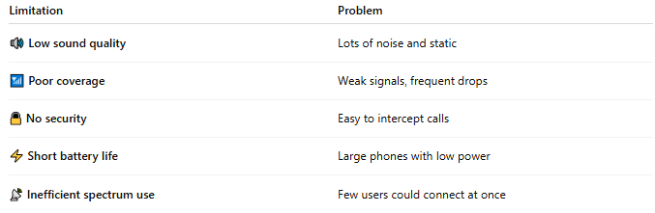

Limitation | Problem
🔊 Low sound quality | Lots of noise and static
📶 Poor coverage | Weak signals, frequent drops
🔒 No security | Easy to intercept calls
⚡ Short battery life | Large phones with low power
📡 Inefficient spectrum use | Few users could connect at once

📱 Devices in the 1G Era:
# Source: Chatgpt (GPT-5-Mini) at [1/23/2026]
- Big, heavy "brick phones" with long antennas
- Examples: Motorola DynaTAC 8000X (1983)

🧭 Transition to 2G:
# Source: Chatgpt (GPT-5-Mini) at [1/23/2026]
Because of its limitations, 1G was soon replaced by 2G, which introduced:
- ✅ Digital voice
- ✅ SMS messaging
- ✅ SIM cards
- ✅ Better security and efficiency

📖 Summary:
# Source: Chatgpt (GPT-5-Mini) at [1/23/2026]
| 🔹 1G was the first mobile network generation — analog, voice-only, and insecure.
| 🔹 It paved the way for the digital revolution that started with 2G.

